
Ahmad Jehad Kobah 20225366

Mohamed Eslam 20224285
Sofian Hashmi Shbili 20220658
Department of Computer Science
Semester: Spring 2025
Course: Computer Graphics (Sp25 - DMT 323 & DM341 - Pr)

Documentation Game Pac Man

Content
1. Introduction 2
2. Game Objective 2
3. Development Tools 2
Languages: 2
Platform: 2
4. Functionality 3
Game Mechanics: 3
Scoring System: 3
Collision Detection: 3
Movement: 3
5. Design Layout 4
Maze Structure: 4
UI Elements: 4
Game Over Screen: 4
Visual Effects: 5
6. Future Improvements 5
Ghost Behavior: 5
Sound Effects: 5
Level Progression: 5
High Score System: 5
Mobile Support: 5
7. Conclusion 5

Pac-Man Game Development Report

1. Introduction
This report provides an overview of the Pac-Man game developed using HTML, CSS, and JavaScript. The game is a simplified recreation of the classic arcade game, featuring Pac-Man, ghosts, pellets, and a maze layout. The objective is to navigate the maze, collect pellets, avoid ghosts, and achieve the highest score possible.

2. Game Objective
- The player controls Pac-Man, guiding him through a maze to consume all pellets.
- Avoid ghosts—colliding with them reduces lives.
- Power pellets (larger dots) temporarily allow Pac-Man to eat ghosts.
- The game ends when:
  - All pellets are collected (win).
  - All lives are lost (game over).

3. Development Tools

Languages:
- HTML5 (Structure)
- CSS3 (Styling & Animations)
- JavaScript (Game Logic & Mechanics)

Platform:
- Web Browser (Chrome, Firefox, Edge, etc.)
- No external libraries—pure vanilla JS for performance and simplicity.

4. Functionality

Game Mechanics:
- Player Movement:
  - Controlled via arrow keys (↑, ↓, ←, →).
  - Smooth movement with collision detection against walls.
- Ghost AI:
  - Random movement with basic pathfinding (avoids walls).
  - Changes direction periodically.
- Pellet System:
  - Regular pellets (10 points).
  - Power pellets (50 points, enable ghost-eating).

Scoring System:
- Regular pellet: +10 points.
- Power pellet: +50 points.
- Score displayed in real-time at the bottom-right.

Collision Detection:
- Wall Collision: Prevents Pac-Man and ghosts from passing through walls.
- Ghost Collision:
  - If Pac-Man touches a ghost:
    - Lose a life.
    - Brief invincibility period (blinking effect).
    - Reset positions (Pac-Man and ghosts return to starting points).

Movement:

- Pac-Man:
  - Moves at tileSize / 16 speed (smooth but challenging).
  - Mouth animation (opens/closes while moving).
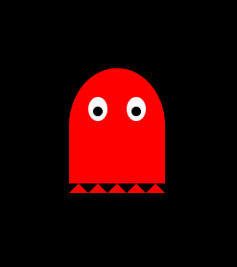
- Ghosts:
  - Move at tileSize / 12 speed (slightly faster than Pac-Man).
  - Random direction changes with cooldown delays.

5. Design Layout

Maze Structure:
- 28x31 grid (448x496 pixels).
- Walls (blue), pellets (white), power pellets (larger white dots).
- Tunnels (left/right wrap-around).
- Ghost house (center area where ghosts spawn).
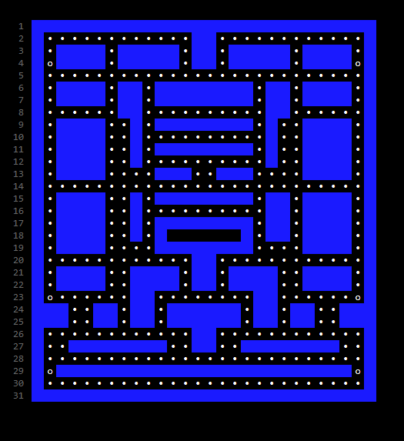

UI Elements:
- Lives Counter (Bottom-Left): Shows remaining lives (max 3).
- Score Counter (Bottom-Right): Updates in real-time.
- Restart Button: Appears after game over/win.

Game Over Screen:
- "GAME OVER" displayed with final score.
- "YOU WIN!" if all pellets are collected.
- Semi-transparent overlay for visibility.

Visual Effects:
- Pac-Man blinking when invincible after losing a life.
- Smooth animations for movement and pellet collection.

6. Future Improvements

Ghost Behavior:
  - Different movement patterns (e.g., chase, scatter, frightened modes).

Sound Effects:
  - Eating pellets, ghost collisions, background music.

Level Progression:
  - Increasing difficulty with faster ghosts.

High Score System:
  - Local storage to save best scores.

Mobile Support:
  - Touch controls for smartphones/tablets.

7. Conclusion
This Pac-Man clone successfully implements core gameplay mechanics while maintaining simplicity. The use of pure JavaScript ensures smooth performance, and the responsive UI enhances player experience. Future updates could expand features like advanced AI, power-ups, and multiplayer modes.
This project demonstrates strong fundamentals in game development using web technologies and serves as a foundation for more complex games.

